Project Design Phase
Problem – Solution Fit Canvas Document
Date | 27 September 2026
Team ID | 6ab1d5ff53fb8f5d0740195d
Project Name | Streamlining IT Procurement: Automating Standard Laptop Orders with Flow Designer
Maximum Marks | 2 Marks

Purpose / Vision:
Automate and streamline the IT procurement lifecycle for Standard Laptops using ServiceNow Flow Designer. The vision is to reduce manual task creation delays, eliminate assignment errors, accelerate request approvals, and provide transparent real-time tracking for end-users and hardware fulfillment teams.
Problem – Solution Fit Canvas Visual Representation:
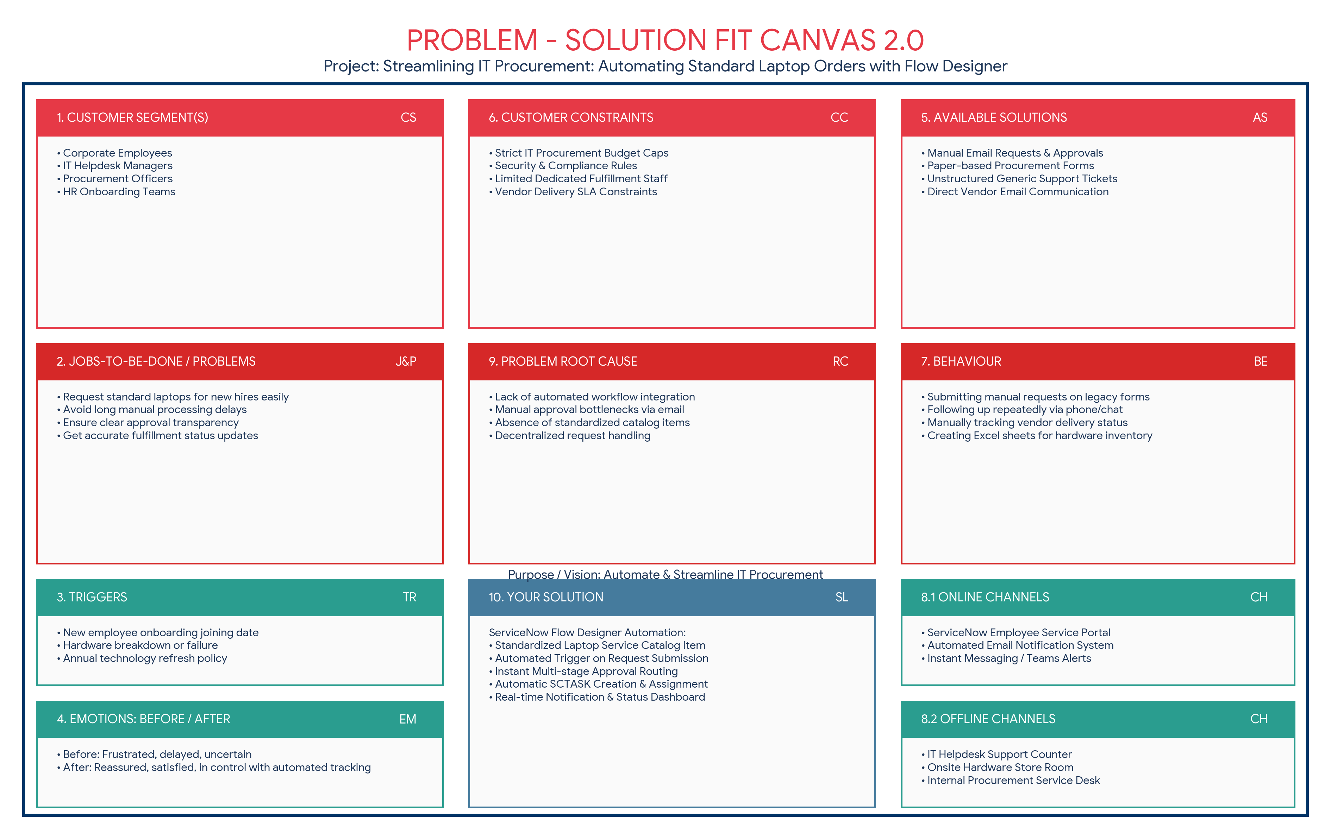
Problem – Solution Fit Canvas Breakdown:
No. | Canvas Block | Project Details & Mapping
1 | 1. CUSTOMER SEGMENT(S) [CS] | Corporate Employees, IT Helpdesk Managers, Procurement Officers, and Onboarding HR Teams.
2 | 2. JOBS-TO-BE-DONE / PROBLEMS [J&P] | Request standard laptops easily for new hires or replacements without tedious manual paperwork or long delays.
3 | 3. TRIGGERS [TR] | New employee joining the company, laptop hardware malfunction, or official technology refresh policy cycle.
4 | 4. EMOTIONS: BEFORE / AFTER [EM] | Before: Frustrated, delayed, uncertain about status.  After: Reassured, satisfied, in control with automated real-time status tracking.
5 | 5. AVAILABLE SOLUTIONS [AS] | Manual email approvals, paper-based procurement request forms, or unstructured IT support tickets.
6 | 6. CUSTOMER CONSTRAINTS [CC] | Strict corporate budget caps, compliance requirements, security access limits, and limited IT fulfillment staff.
7 | 7. BEHAVIOUR [BE] | Employees submit requests via internal portal and follow up manually with IT via chat/email for status updates.
8 | 8. CHANNELS OF BEHAVIOUR [CH] | Online: ServiceNow Employee Service Portal, Automated Email Notifications.  Offline: IT Helpdesk Counter, Internal Procurement Desk.
9 | 9. PROBLEM ROOT CAUSE [RC] | Lack of automated workflow integration, manual approval bottlenecks, and absence of standardized catalog items.
10 | 10. YOUR SOLUTION [SL] | Automated IT Procurement using ServiceNow Flow Designer: Standardized Service Catalog items with auto-triggered approval routing and instant SCTASK assignment to Hardware Team.

